**Course Specialist Year 12 Test Three 2022**

Student name: ________________ Teacher name: ________________

**Task type: Response**

**Time allowed for this task: _____40______ mins**

**Number of questions: _____6______**

**Materials required:** NO classpads nor calculators

Standard items: Pens (blue/black preferred), pencils (including coloured), sharpener, correction fluid/tape, eraser, ruler, highlighters

Special items: Drawing instruments, templates, notes on one unfolded sheet of   
A4 paper, and up to three calculators approved for use in the WACE examinations

**Marks available: __40____ marks**

**Task weighting: _10___%**

**Formula sheet provided: Yes**

**Note: All part questions worth more than 2 marks require working to obtain full marks.**

**NO classpads nor calculators!**

Q1 (3 & 3= 6 marks) (3.3.9-3.3.10)

1. Solve the following set of linear equations.



|  |
| --- |
| **Solution** |
|  |
| **Specific behaviours** |
| 🗸 eliminates one variable from two equations  🗸 eliminates two variables from one equation  🗸 solves for all 3 variables |

1. Consider the system below,



Determine the values of  such that there are:

1. Unique solution
2. Infinite solutions
3. No solutions.

|  |
| --- |
| **Solution** |
|  |
| **Specific behaviours** |
| 🗸 eliminates two variables from one equation  🗸 determines values for uniqueness  🗸 determines all values for infinite and no solutions |

Q2 (2, 2, 2 & 3 = 9 marks) (3.3.11, 3.3.13)

A particle moves such that at time  seconds the velocity is . The particle is initially at the origin.

Determine:

1. The position vector at time  second.

|  |
| --- |
| **Solution** |
|  |
| **Specific behaviours** |
| 🗸 integrates and states a constant C  🗸 states r with t=1 |

1. The acceleration of the particle at  second.

|  |
| --- |
| **Solution** |
|  |
| **Specific behaviours** |
| 🗸 diff v  🗸 states with t=1 |

1. The speed of the particle at  seconds.

|  |
| --- |
| **Solution** |
|  |
| **Specific behaviours** |
| 🗸 determines velocity at t=2  🗸 determines speed, no need to simplfy |

1. The times when the velocity is perpendicular to the acceleration.

|  |
| --- |
| **Solution** |
|  |
| **Specific behaviours** |
| 🗸 uses dot product  🗸 equates to zero  🗸 states one non negative result |

Q3 (4, 3 & 2 = 9 marks) (3.3.12, 3.3.13, 3.3.15)

Consider a particle that is projected from the top of a cliff of height 30 metres with a speed of  metres per second at an angle of  to the horizontal. Assume that the acceleration is constant at  towards the centre of the Earth. Let the origin of cartesian axes be at the base of the cliff as shown below with the appropriate unit vectors .

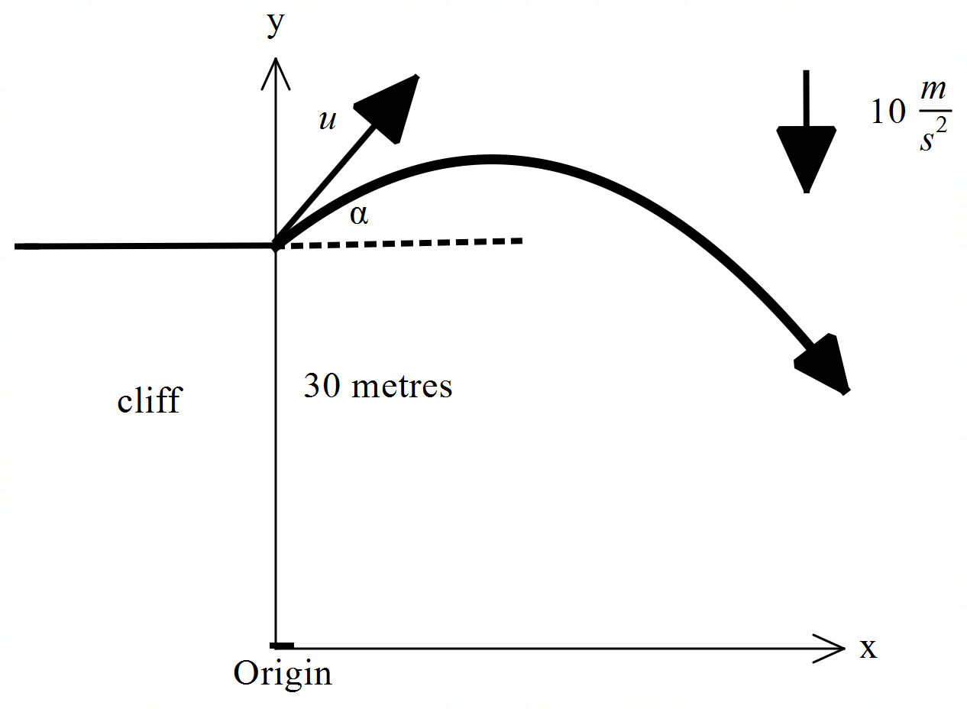

Let .

1. Using vector integration, show how to derive the position vector  at time  seconds in terms of . Show all steps.

|  |
| --- |
| **Solution** |
|  |
| **Specific behaviours** |
| 🗸 integrates acceleration with plus constant  🗸 solves for constant in terms of two variables  🗸 integrates velocity with plus constant  🗸 solves for constant and states r in terms of t |

1. Show how to derive the cartesian equation for the path of the particle in terms of .

|  |
| --- |
| **Solution** |
|  |
| **Specific behaviours** |
| 🗸 expresses t in terms of x  🗸 subs into y parametric equation  🗸 states cartesian equation without any reference to t |

1. Set up an equation in terms of  ONLY, but do not solve, that would allow the range

() to be determined where the particle hits the floor from the base of the cliff.

|  |
| --- |
| **Solution** |
|  |
| **Specific behaviours** |
| 🗸 uses y=0  🗸 uses tan only with reference to angle in two terms of equation |

Q4 (4 marks) (4.2.1)

If , determine  in terms of only.

|  |
| --- |
| **Solution** |
|  |
| **Specific behaviours** |
| 🗸 implicit diff of original equation  🗸 obtains expression for first derivative  🗸 implicit diff involving first derivative (or first implicit equation) shown  🗸 expression of second derivative in terms of x & y only, no need to simplify |

Q5 (3 & 4 = 7 marks) (4.2.1)

Determine the following integrals:

1. 

|  |
| --- |
| **Solution** |
|  |
| **Specific behaviours** |
| 🗸 changes to variable u and du  🗸 changes limits to u  🗸 obtains numerical value(unsimplfied) |

1. 

|  |
| --- |
| **Solution** |
|  |
| **Specific behaviours** |
| 🗸 expresses as two partial fractions with THREE constants  🗸 solves two constants  🗸 solves all three constants showing derivation for all  🗸 obtains expression for integral |

Q6 (5 marks) (4.1.1, 4.2.2)

Consider a lighthouse that is 50 metres away from the shore. On the shore is a long brick wall. The light on the lighthouse is rotating at 4 revolutions per second. Determine the exact speed of the dot of light on the wall at a point 3 metres from the point directly opposite the lighthouse as shown below.

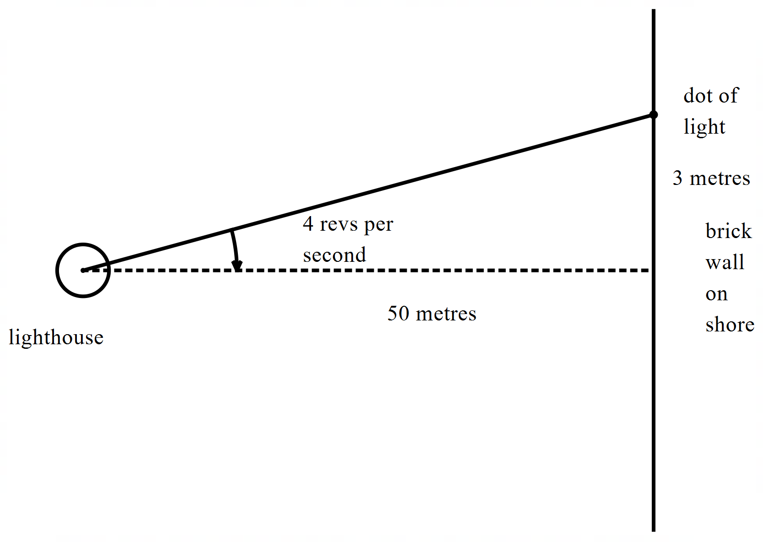

|  |
| --- |
| **Solution** |
|  |
| **Specific behaviours** |
| 🗸 sets up equation between angle and distance along wall  🗸determines rate of angle in radians  🗸 uses implicit diff or related rates to link all rates  🗸 determines exact value of tan of angle  🗸 states an exact expression of speed |